Kvm

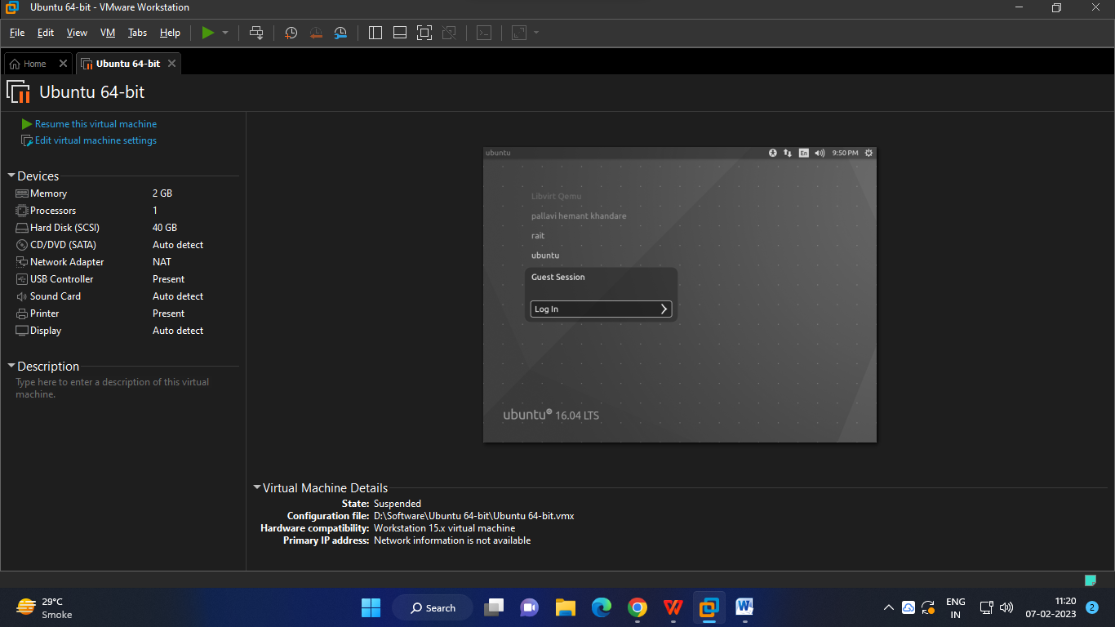

Login with Ubuntu

Password :- Ubuntu

Open in terminal

|  |
| --- |
| sudo grep -c "svm\|vmx" /proc/cpuinfo  sudo apt-get install qemu-kvm libvirt-bin bridge-utils virt-manager  sudo adduser rait  sudo adduser rait libvirtd  virsh -c qemu:///system list  virt-manager |

|  |
| --- |
| ubuntu@ubuntu:~$ sudo grep -c "svm\|vmx" /proc/cpuinfo  [sudo] password for ubuntu:  0  ubuntu@ubuntu:~$ sudo apt-get install qemu-kvm libvirt-bin bridge-utils virt-manager  Reading package lists... Done  Building dependency tree  Reading state information... Done  bridge-utils is already the newest version (1.5-9ubuntu1).  libvirt-bin is already the newest version (1.3.1-1ubuntu10.31).  qemu-kvm is already the newest version (1:2.5+dfsg-5ubuntu10.51).  virt-manager is already the newest version (1:1.3.2-3ubuntu1.16.04.4).  0 upgraded, 0 newly installed, 0 to remove and 257 not upgraded.  ubuntu@ubuntu:~$ sudo adduser shilpa  Adding user `shilpa' ...  Adding new group `shilpa' (1003) ...  Adding new user `shilpa' (1003) with group `shilpa' ...  Creating home directory `/home/shilpa' ...  Copying files from `/etc/skel' ...  Enter new UNIX password:  Retype new UNIX password:  passwd: password updated successfully  Changing the user information for shilpa  Enter the new value, or press ENTER for the default  Full Name []: shilpa singh  Room Number []: 465  Work Phone []: 5758  Home Phone []: 578  Other []: jkfjkh  Is the information correct? [Y/n] y  ubuntu@ubuntu:~$ sudo adduser shilpa libvirtd  Adding user ‘shilpa’ to the group ‘libvirtd’..  Adding user ‘shilpa’ to the group ‘libvirtd’  Done.  ubuntu@ubuntu:~$ virsh -c qemu:///system list  Id Name State  ----------------------------------------------------  ubuntu@ubuntu:~$ virt-manager  ubuntu@ubuntu:~$ |

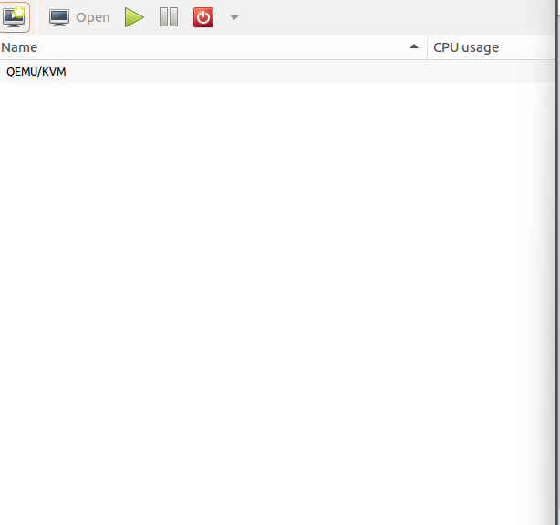

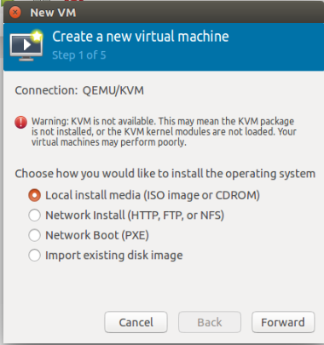

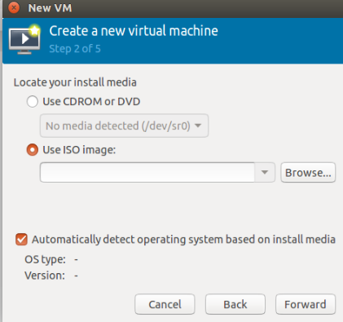

**Practical 7**

Create RSS file in notepad

|  |
| --- |
| <?xml version="1.0" encoding="UTF-8"?>  <rss version="2.0">  <channel>  <title>W3Schools Home Page</title>  <link>https://www.w3schools.com</link>  <description>Free web building tutorials</description>  <item>  <title>RSS Tutorial</title>  <link>https://www.w3schools.com/xml/xml_rss.asp</link>  <description>New RSS tutorial on W3Schools</description>  </item>  <item>  <title>XML Tutorial</title>  <link>https://www.w3schools.com/xml</link>  <description>New XML tutorial on W3Schools</description>  </item>  </channel>  </rss> |

Open visual studio code 2019

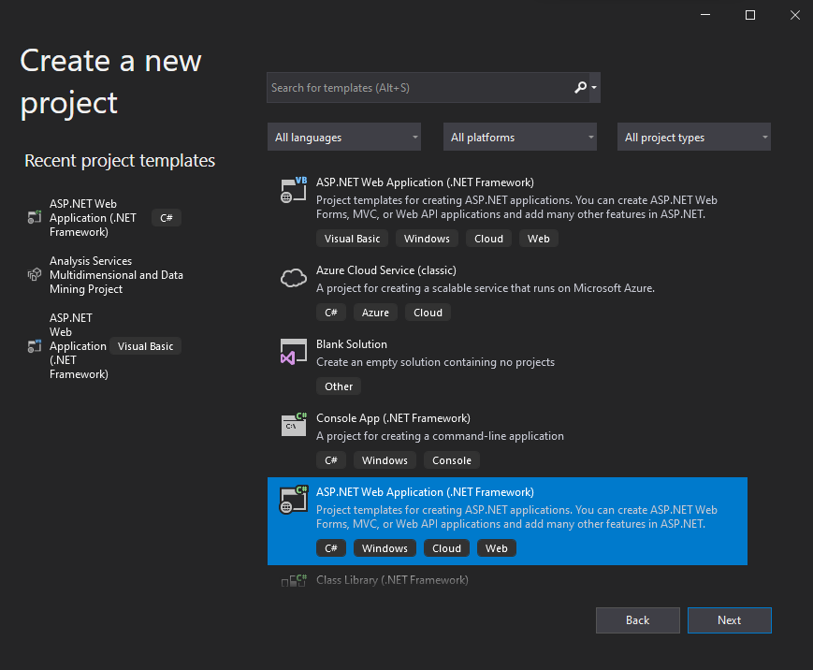

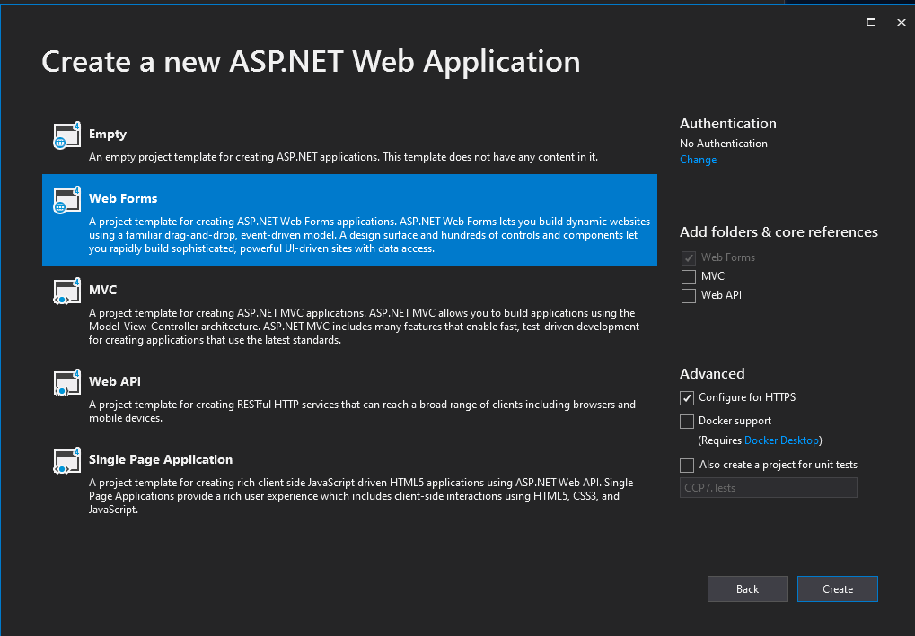

Right click on created project name in solution explorer

Add existing item-> xml file

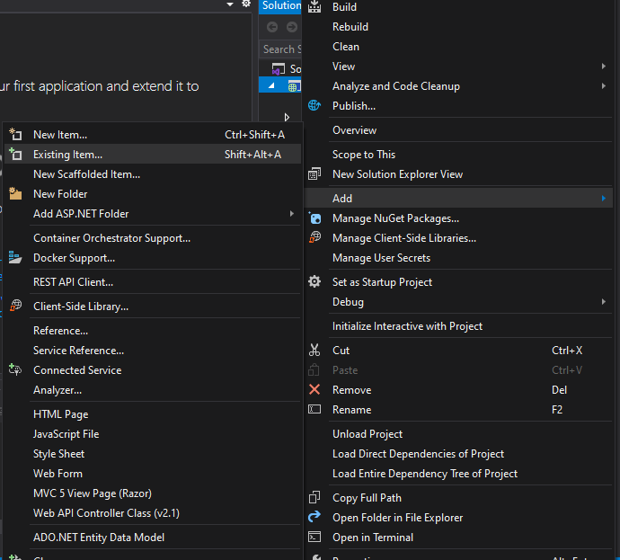

Open Default.aspx in solution explorer

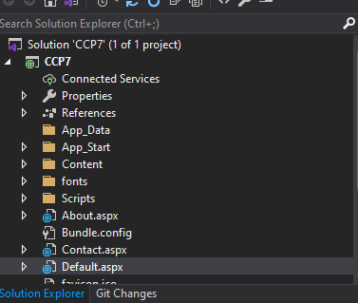

Write one line code at the end

|  |
| --- |
| <p>Here is your feed <a href="rss.xml">feed</a>.</p> |

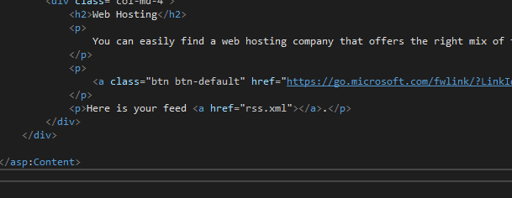

Run

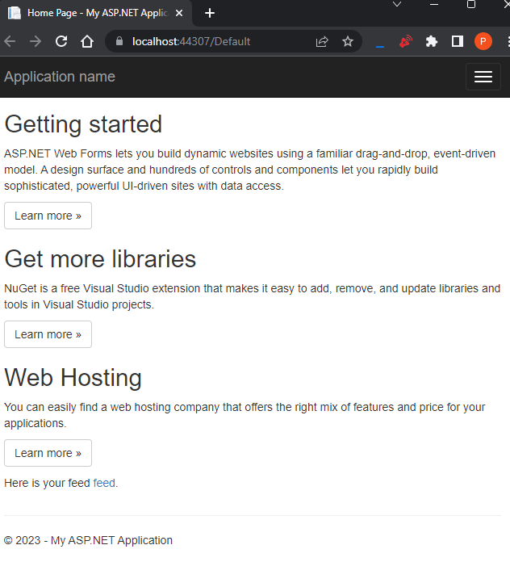

Click on feed

Output:-

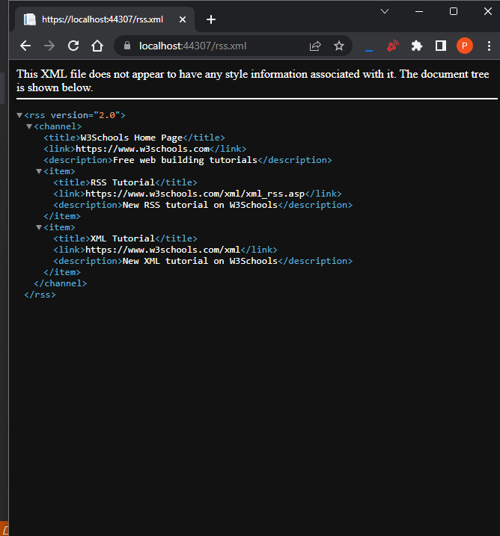

Pratical 8

Single sign on

**1:** Open chrome->go to the URL-> <https://auth0.com/learn/how-to-implement-single-sign-on/>

authentication>  
social>  
three dot>  
try coinnection